**Adobe Premiere Pro 2020**

**Basics Primer**

**Quick Navigation -**

File System 2

File Color Match 3

Basic Audio Mix 4

How to Insert Titles 5

How to Insert Basic Shapes 6

Prepping Clip for Publishing 7

Publishing Presets 8

### File System

If anyone else is going to work with the project, then a common file structure is needed to share the project file and them be able to access it without dealing with broken links.

Best practice is to set the same folder structure up both in the Windows File system and in Premiere.

It is super important that the folder and file names match exactly.

To set them up in Premiere, right click in the “Import Media” zone and click New Bin.

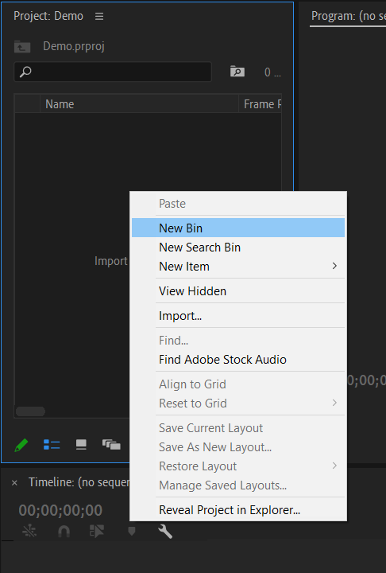

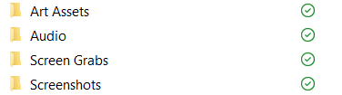

Useful folder names that seem to be used through multiple projects –

* Audio
* Art Assets
* Screen Grabs
* Screenshots

### File Color Match

Premiere imports files with a color assigned to them, with some overlapping in color. It is generally a good idea to only have one color representing one general category.

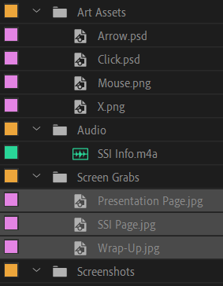

To set a color - select all relevant files and the bin, right click, select label, and then pick a color.

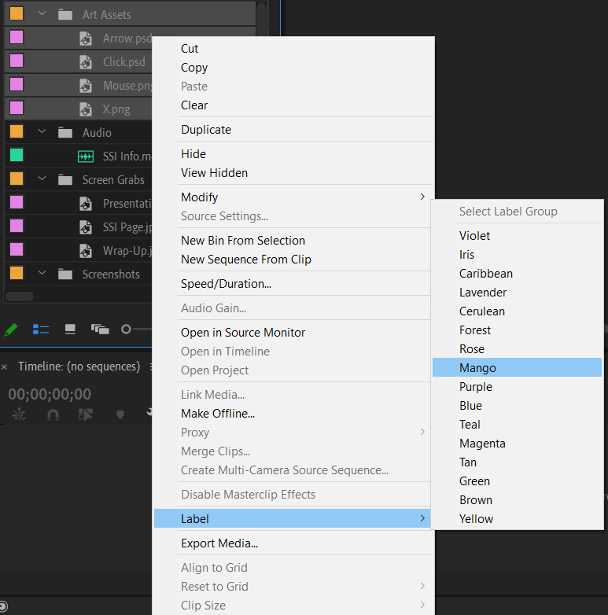

Either a common color system can be developed or it can be left up to each person on what color scheme they want to use. I personally make Audio files Caribbean, Art Assets files Iris, Screen Grabs files Teal, and Screenshots files Lavender.

### Basic Audio Mix

There are a couple of options for Adjusting Audio. The most basic is to just select the Essential Sound tab and then click what type of Audio it is. This will sweep through and apply basic presets that are programed into Premiere to the track.

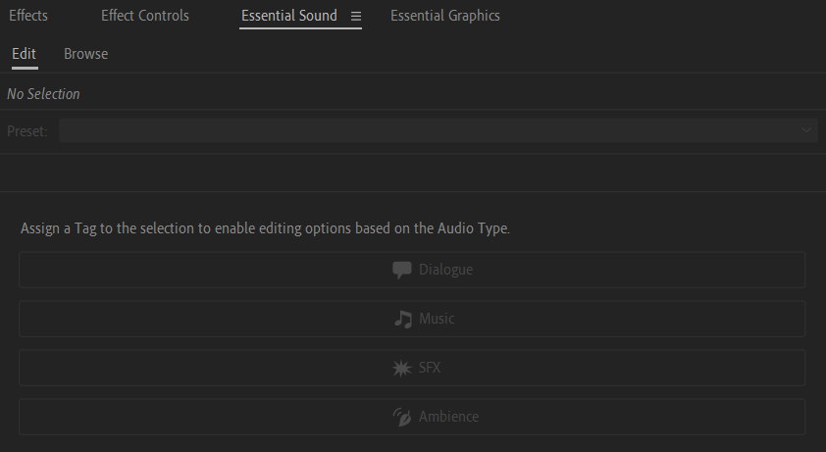

If the goal is to go a bit further, then click on the Audio tab, click the arrow in the upper left corner, and the audio track mixer will open.

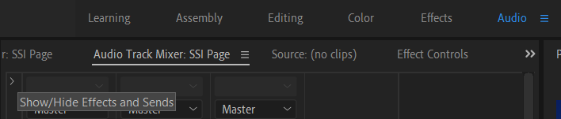

The function slots work with a top-to-bottom approach, so the first function will execute, then the second, etc. The three basic ones are Noise Reduction/Restoration -> DeNoise, Filter and EQ -> Parametric Equalizer, and then Amplitude and Compression -> Multiband Compressor. Once the function has been selected to go in and edit the setting, just double click on the function name.

For DeNoise the main thing to adjust is the Amount should be set to 10%



Adjustments for the Parametric Equalizer will depend on if you are working with a female or male voice. For a female voice change the third column to 400 Hz, 3 dB, 1 Q/Width and the fifth column to 4000 Hz, 5 dB, 1 Q/Width. For a male voice change the third column to 200 Hz, 3 dB, 1 Q/Width and the fifth column to 3200 Hz, 5 dB, 1 Q/Width.

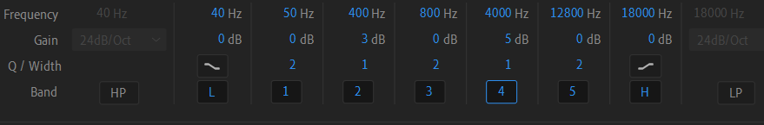

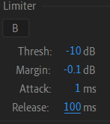For Multiband Compressor, change the preset to Broadcast, then change the limiter attack to 1, and the release to 100.



### How to Insert Titles

Click on the Essentials Graphics tab to bring up options.

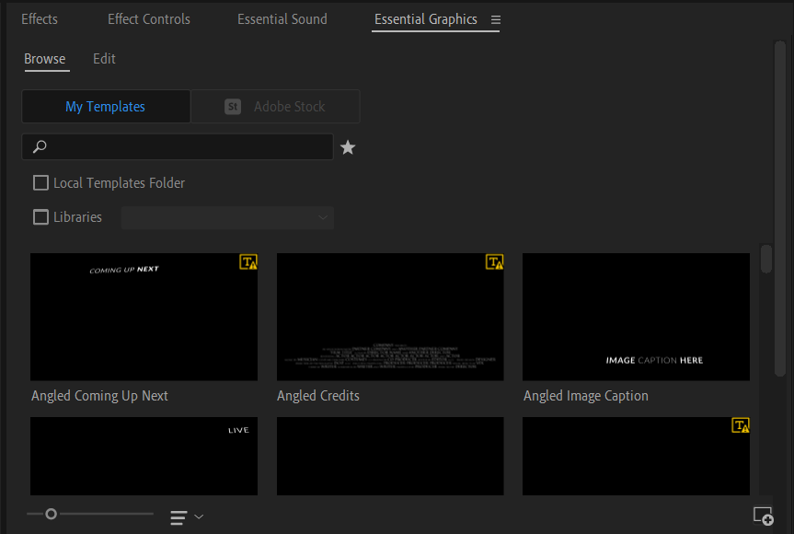

Once a title that will work is found, click and drag it onto the timeline. Clicking on the graphic box that is on the timeline will change the options in the Essential Graphics tab.

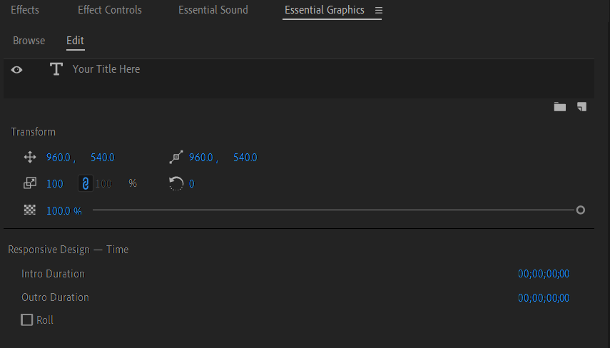

To edit the text, click on it in the preview pane, and type in what it should read. Then scroll down on the Essential Graphic tab to change the font of the text, the size, and the appearance.

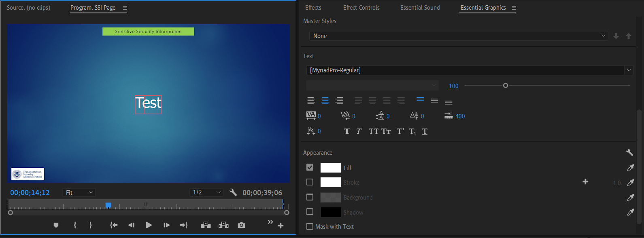

### How to Insert Basic Shapes

The basic set up of this needs to be done on the Graphics Tab, then once its set for the project it can be accessed through the quick tool panel on the main page set-up. Left click and hold over the Pen Tool and a pop-up window will open. Click either the Rectangle Tool or the Ellipse Tool that will be the call attention shapes for the project.

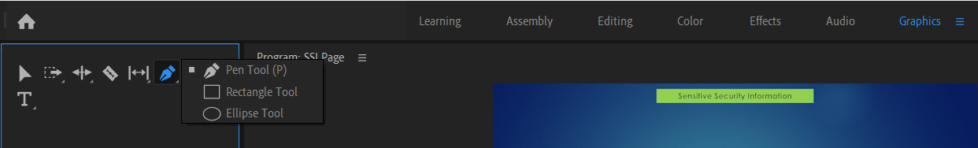

Then in the bottom right-hand corner, un-click the fill button and click the stroke button. The stroke is how wide the outline of the shape will be. I generally use a value of 5. To change the color of the shapes outline, click on the white box, which will open a color picker. It is generally a good idea to click the Only Web Color box to reduce frustration of the color appearing differently in web browsers. For consistency across projects, writing down the # of the chosen color for call out boxes is a good practice. Then instead of having to use the mouse to try and find the specific color, the value can just be typed in.

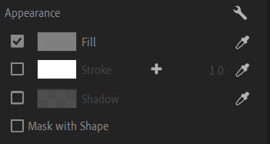 -> 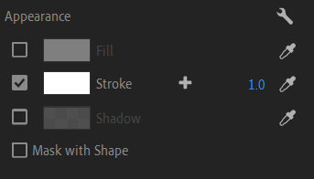

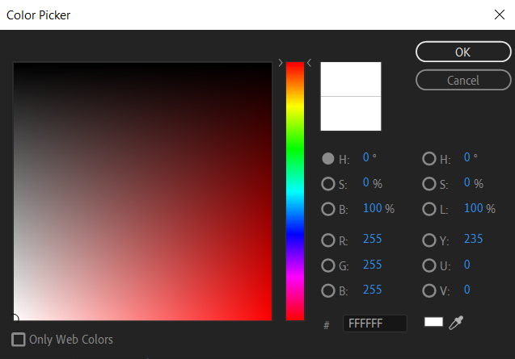

Once done with set-up back on the standard page, the pen icon has changed to the chosen shape and can be used. It is possible to navigate between the pen, rectangle, and ellipse tools from the standard page, but the Fill and Stroke settings cannot be adjusted there.

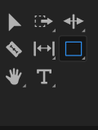 -> 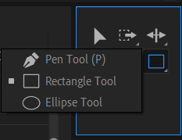

### Prepping Clip for Publishing

This cannot be done until there is a timeline to export as media. Once a timeline has been completed with audio, content, etc. place the curser at the beginning of the timeline and press I. Then place the curser at the end of the timeline and press O. This will select the video area that needs to be exported.

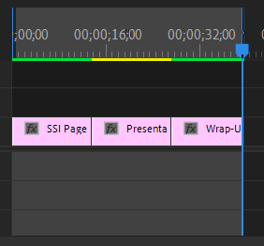

Then click File, Export, Media. This opens a pop-up box with options of how to publish the clip.

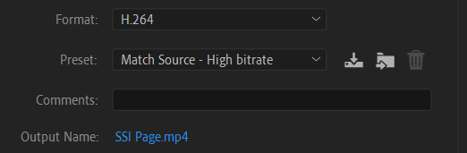

Change the Output Name to reflect what the file name should be; it automatically defaults to the first thing added to the timeline. It is suggested to change the format to H.264 as it is widely supported across multiple players and web browsers. Then change the preset to one of the custom ones described below.

### Publishing Presets

Here are some suggested presets to set up. I personally use the 720p for all of my projects, and the instructions will walk you through how to set this up. Note: It is a pain to use this as you cannot expand the box and must deal with the small area presented as you scroll.

Start by unchecking the Match Source box, change the Width to 1280. Height will auto adjust to 720.

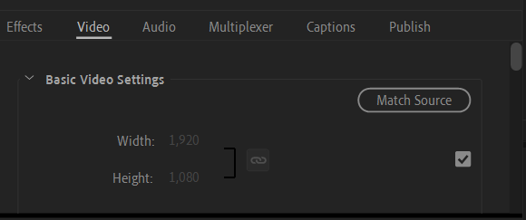-> 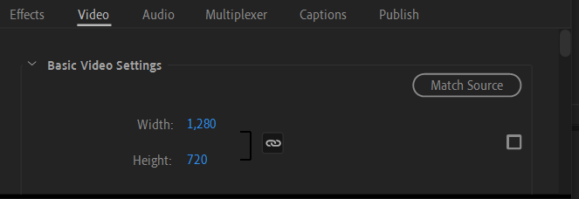

Scroll down until you see “Render at Max Depth” make sure it is checked.

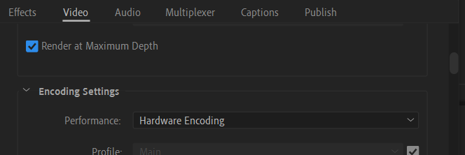

Then continue scrolling to the Bitrate Setting section. Change the VBR, 1 Pass to VBR, 2 Pass. Change the target to 18 and the Max to 20.

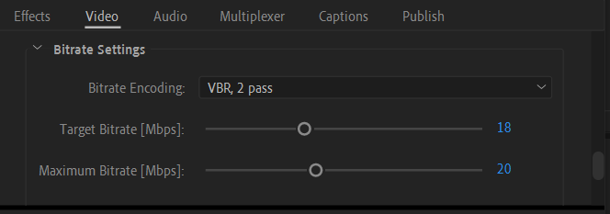

Make sure the Maximum Render Quality is checked under the Video tab. Then click the button to the right of Custom and save the Preset at 720p.

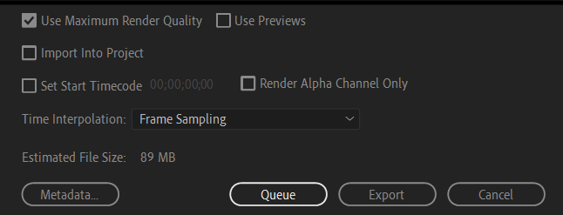

Some additional presets that could be set up are 1080p or 480p.

1080p -> from the 720p preset check the Box under Match Source, then change the Target Bitrate to 26, Max Bitrate to 28. This preset is the best, but makes the saved mp4 file huge.

480p -> from the 720p preset change the match source to 852 x 480, then change the Target Bitrate to 8, Max Bitrate to 10. This preset is the smallest file size but video tends to be grainy.